Opening page:

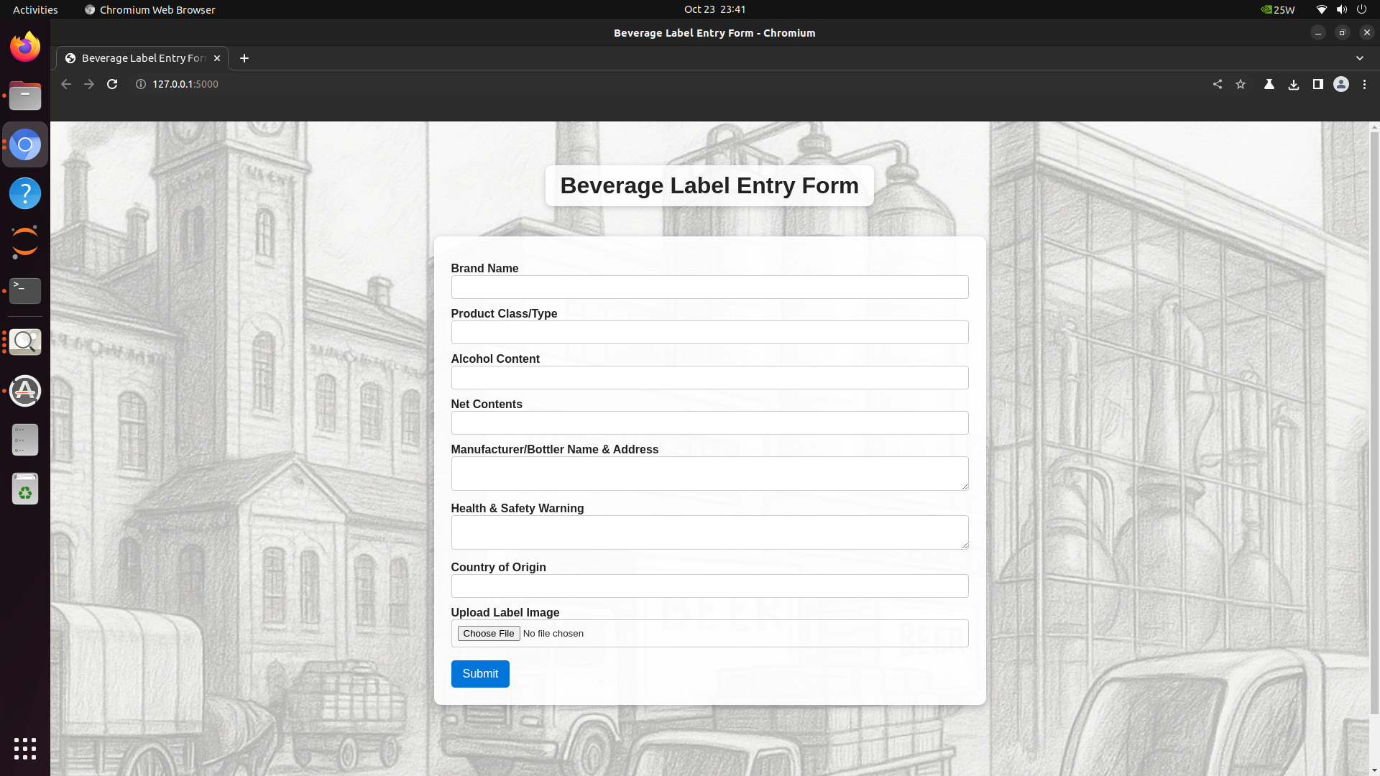

Run locally, you get the following based on data entered include image. In case of wrong image, the entries are kept for fast update.

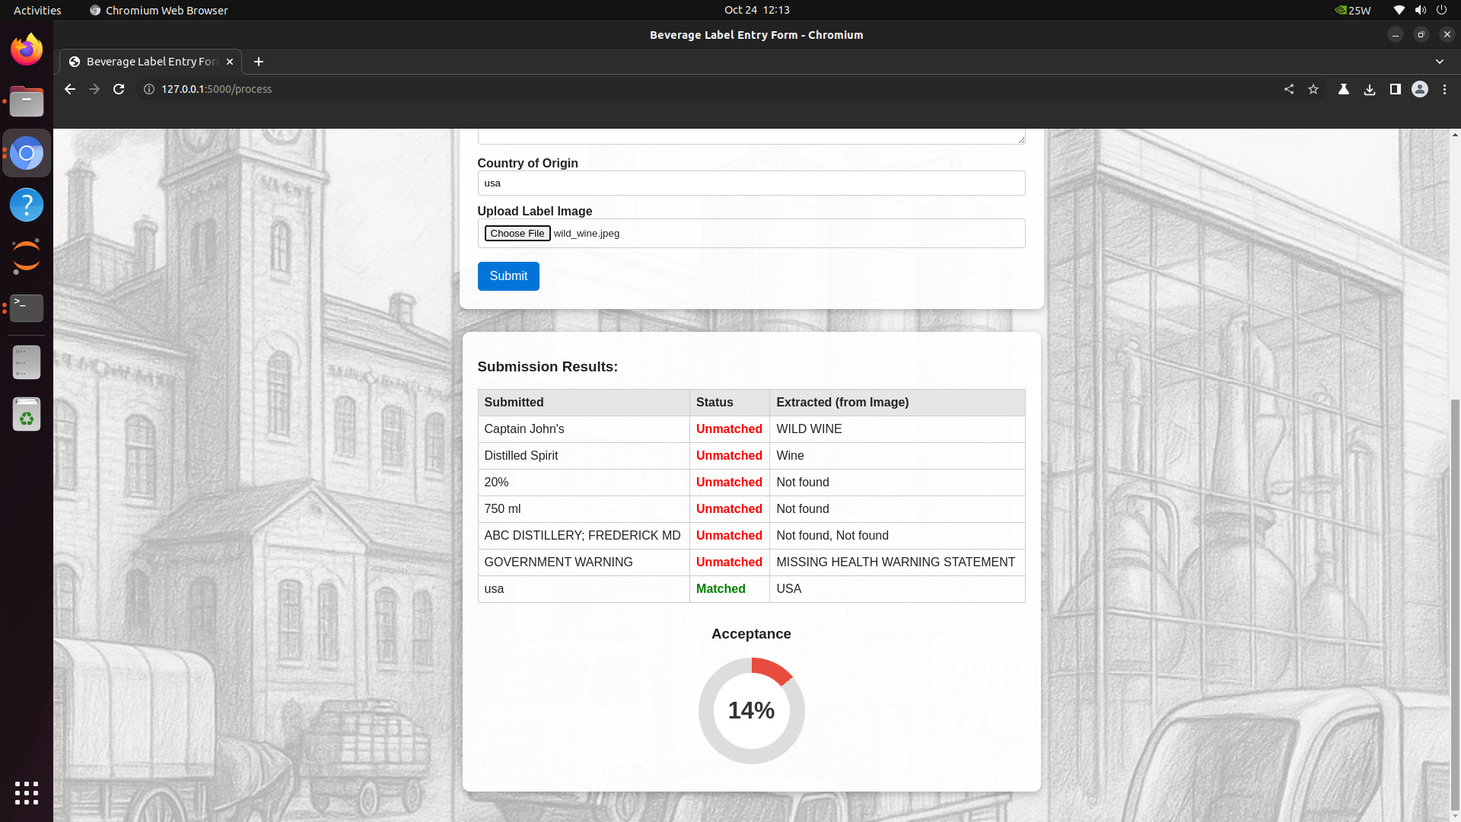

Color of the progress pie chart match the entry acceptance level

Partial acceptance:

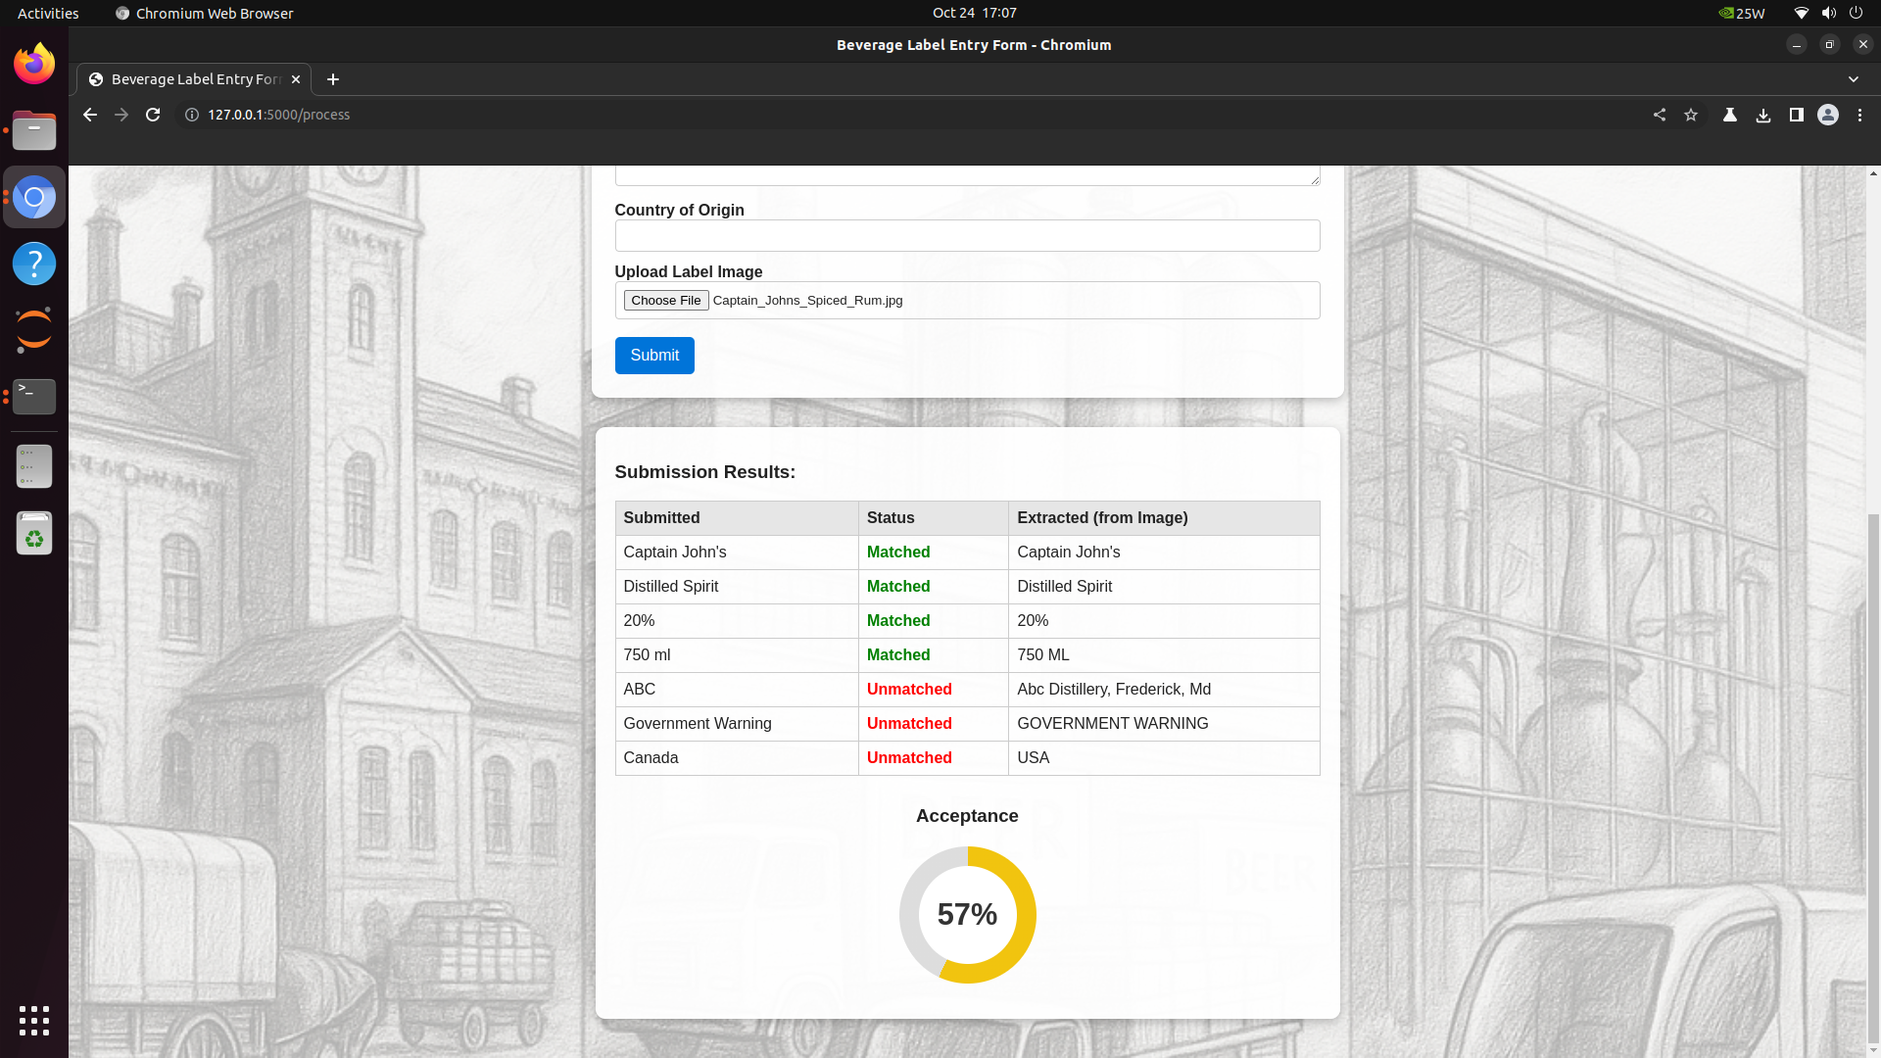

And when all is right:

